Global Classroom

Testing Report

E – Voting System

Website

DT282/3



Student Names & Numbers:

* Eoin Smyth [C14427202@mydit.ie](mailto:C14427202@mydit.ie)
* Robert Wijntjes [C14356786@mydit.ie](mailto:C14356786@mydit.ie)
* Jake Young [C14706715@mydit.ie](mailto:C14706715@mydit.ie)
* Elliot Igoe [C14733411@mydit.ie](mailto:C14733411@mydit.ie)
* Eryk Szlachetka [C14386641@mydit.ie](mailto:C14386641@mydit.ie)

Due Date: 28/04/17

Table of Contents

Login Page: 3

Entrance Page 4

Add User: 5

Delete User: 6

Add Polls: 7

User Information: 8

Settings: 9

Tools Used 11

Google Developer Tools 11

# Login Page:

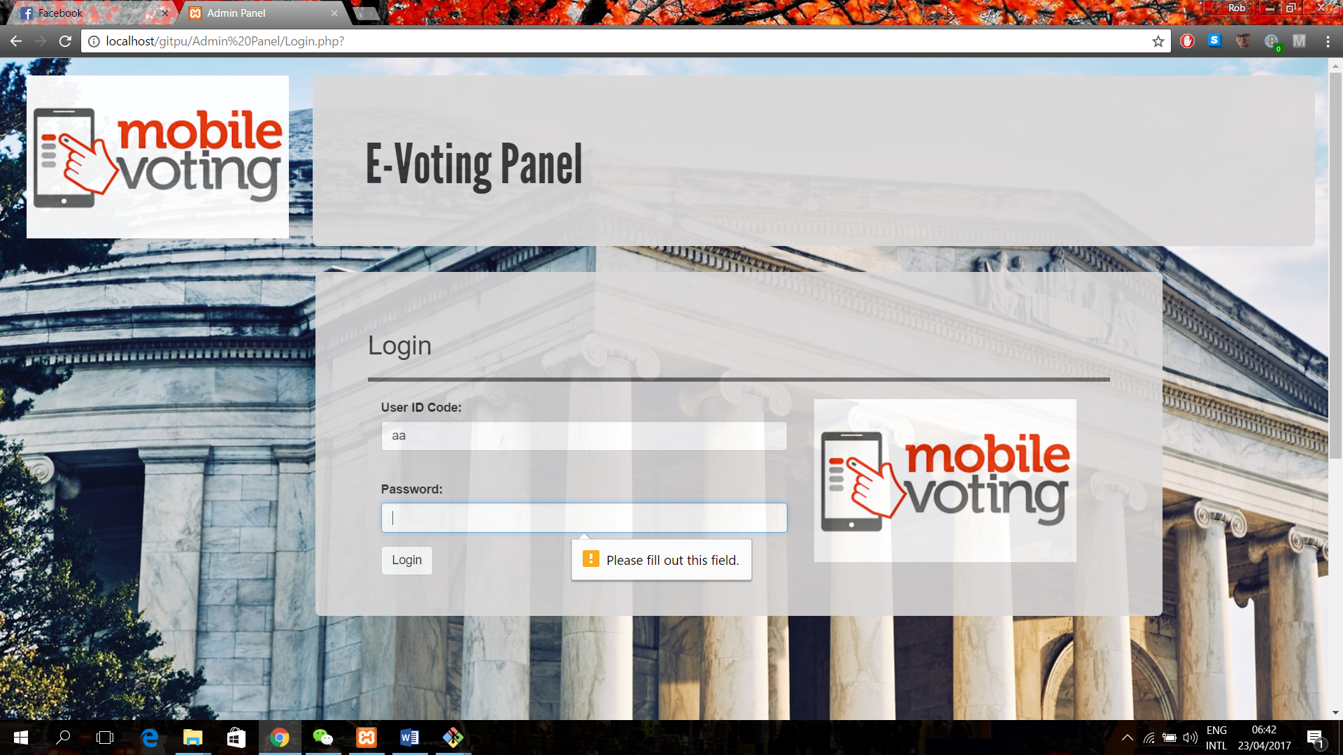

Login feature has not yet been implemented but field validation and frontend structure worked as intended.

# Entrance Page

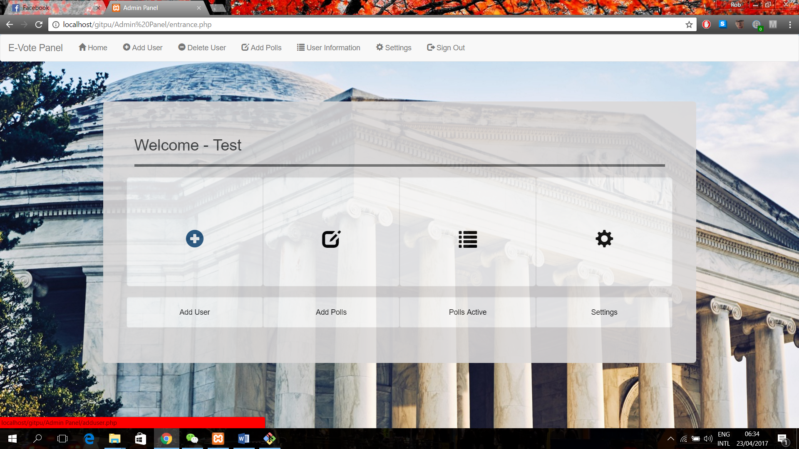

Frontend features worked as intended such as structure and the interaction buttons. Minor Backend features such as PHP to attach a toolbar also worked as intended. The page links are all also working correctly.

# Add User:

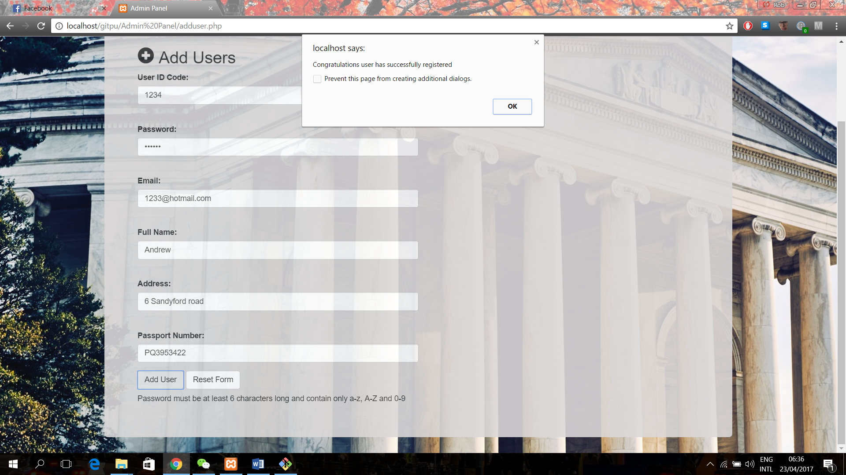

Frontend features worked as intended such as the grouping of the form and stylesheet. Backend features all worked such as the submission of the form and field validation.

These backend submissions can be seen on the database on Parse.com as seen below:

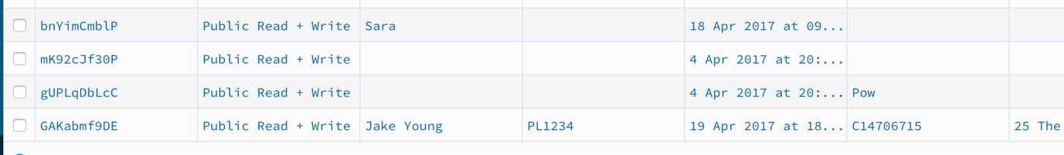

# Delete User:

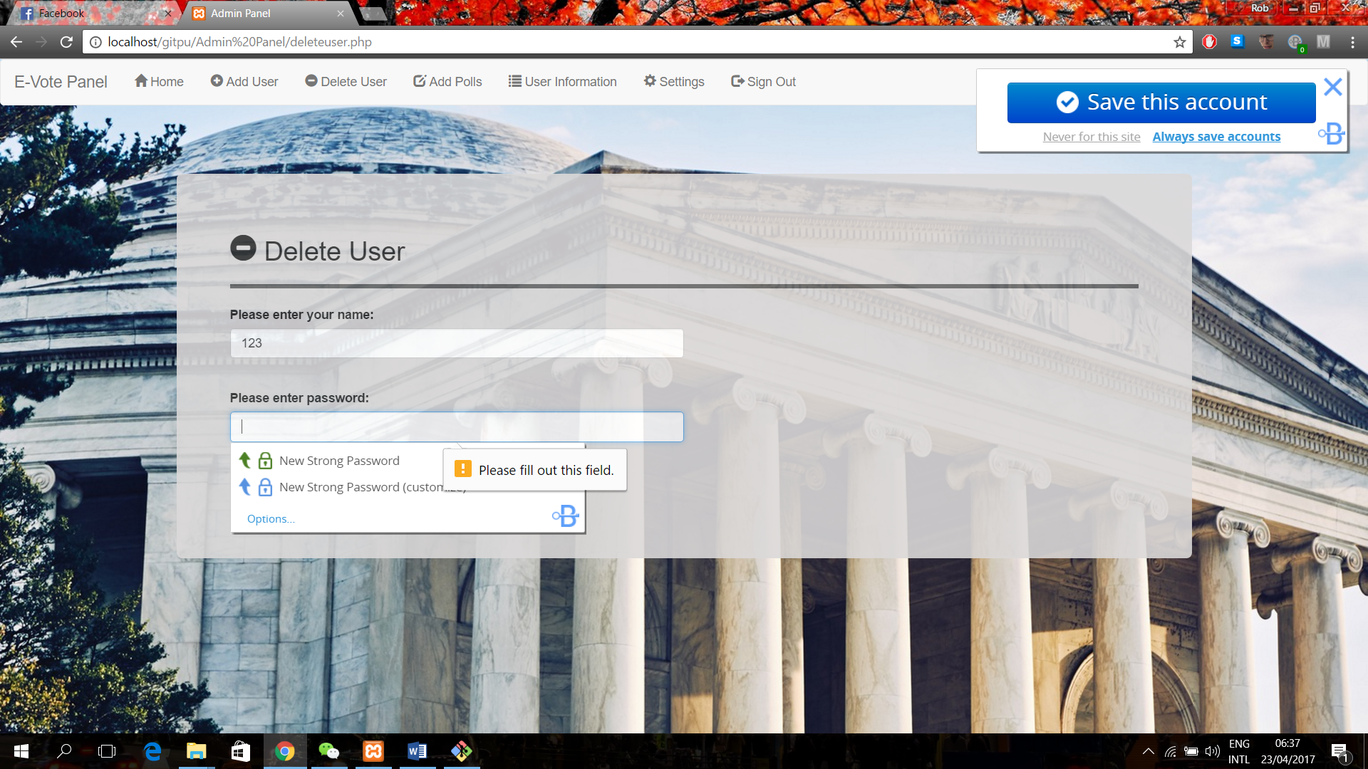

Delete user frontend all worked as intended and backend field validation worked but delete user not implemented.

# Add Polls:

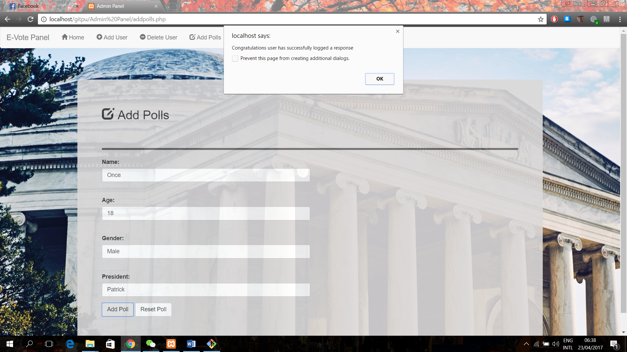

Frontend features all worked as intended and backend features for form submission and field validation all worked.

# User Information:

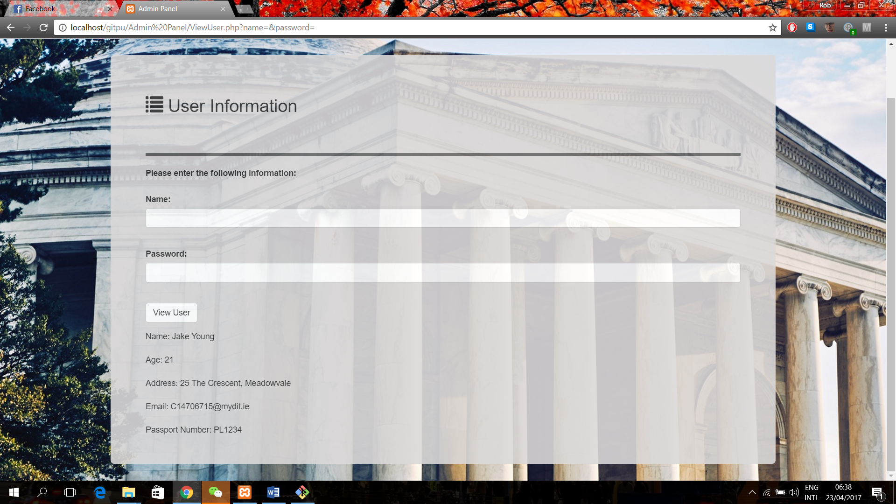

Frontend features which ask for user to enter credentials work. Backend feature working for demonstration purposes only as it is not fully implemented.

# Settings:

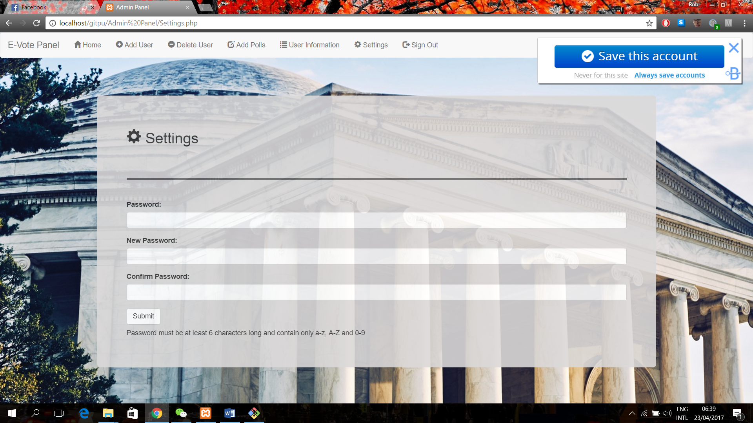

Password content checks implemented. Also form submission in JavaScript not implemented.

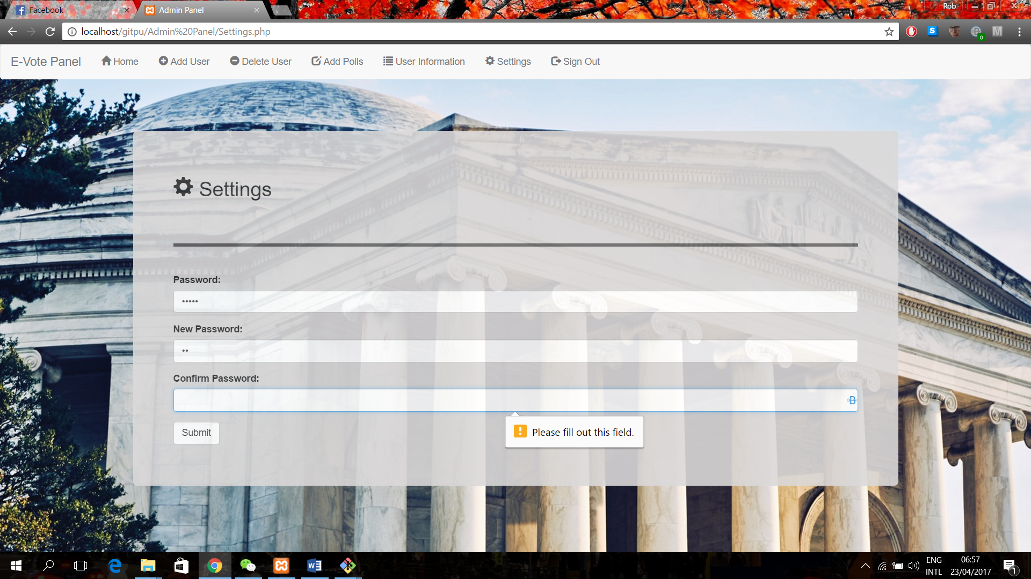

Checking if every field in the form is filled out so that there can be no missing information submitted to the database. All worked as intended.

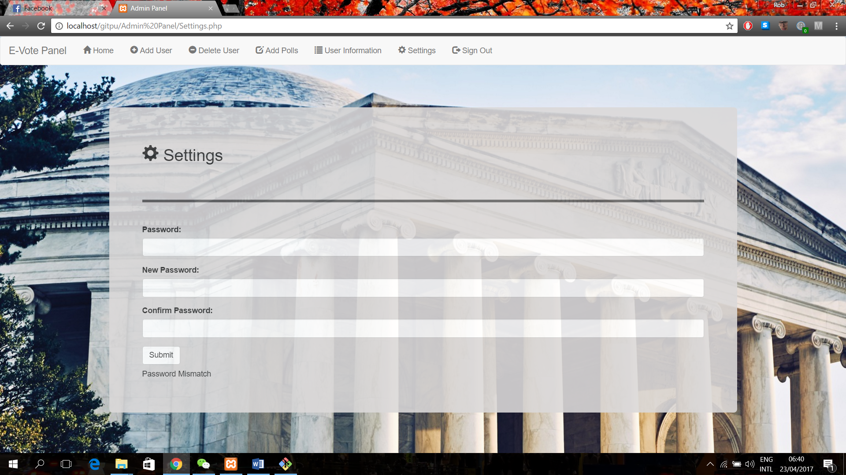

Checking for password matches when verifying the password.

# Tools Used

## Google Developer Tools

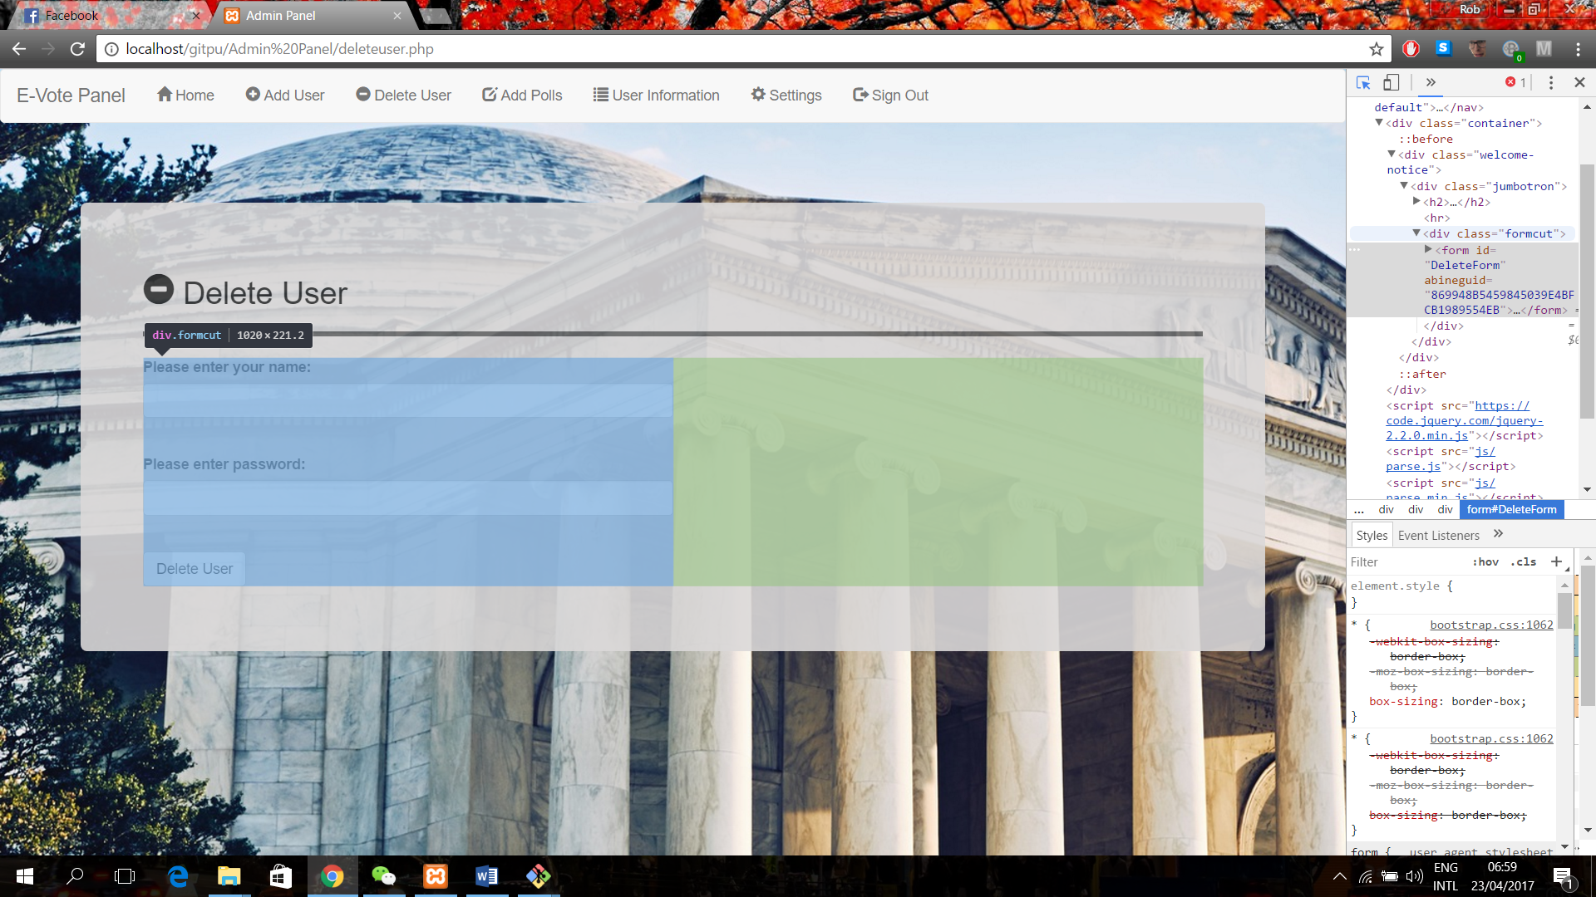

This tool is used to check the frontend sections of the website. Mostly how the website is split into its different divs.

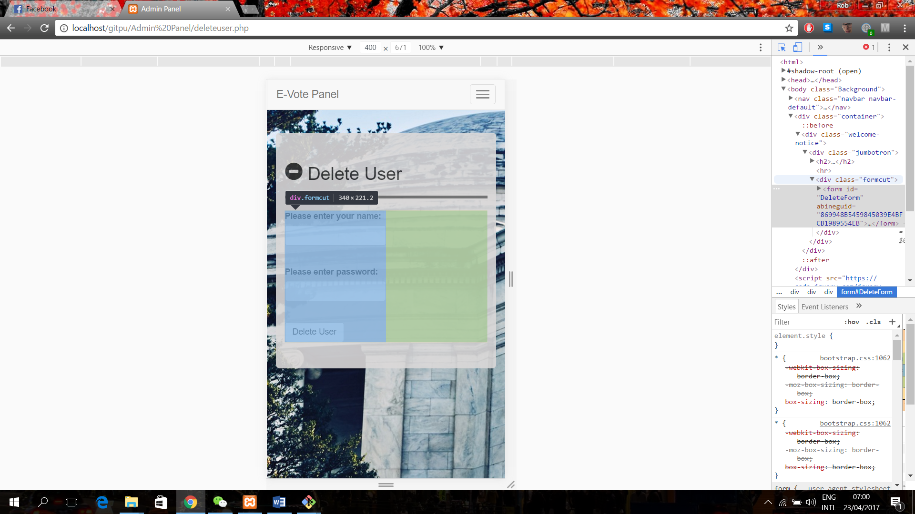

This tool is mostly used to check your websites compatibility with other devices and therefore other screen sizes and interaction types.

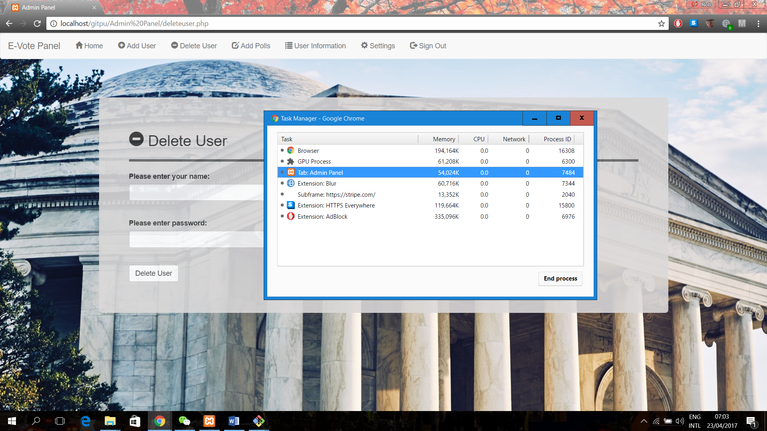

This tool is used to check the memory consumption of your webpage to insure it is not too memory intensive.